XOR Neural Network solver

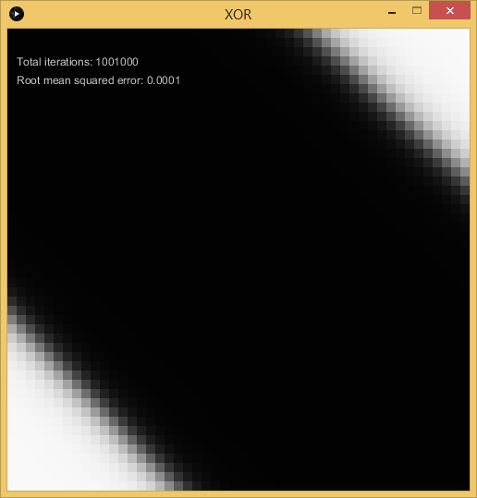

Solved weights and biases for a 2 Input, 4 Hidden, another 4 Hidden and 1 Output layers:

Hidden [0] - Random limit: 0.7071
Hidden [1] - Random limit: 0.5000
Output - Random limit: 0.5000

Final weights and biases:

Hidden weights [0]
11.3568 -11.8346
1.6819 -2.6859
11.3480 -10.8038
-4.4477 4.0639

Hidden weights [1]
-3.9917 -0.4183 4.1195 -0.7995
6.4705 0.3422 -5.8001 0.9875
6.2561 0.3373 -5.6464 0.6153
6.7996 0.4331 -6.2588 1.0090

Hidden bias [0]
-6.4181
-3.5878
6.3976
-3.9401

Hidden bias [1]
-0.7232
1.5902
1.5471
1.8789

Output weights
-2.0597 2.6364 2.4368 3.0185

Output bias
-2.7128

